

**Project Report on Implementing CRM For Result Tracking of Candidate With Internal Marks**

**By: -**

**Ayush Kumar Dubey**

##### PROJECT DESCRIPTION: -

The administrator should be able to create all base data including Semester, Candidate, Course, and Lecturer, Lecturer should have the ability to create Internal Results, Dean, who is one of the Lecturer, should be the only one with the ability to update Internal Results, Re-evaluation Can be initialized by Candidate for all Internal Results. Now only the dean can update the marks after re-evaluation.

##### **Introduction: -**

The Improved features of CRM software have increased both its complexity and necessity. Nearly half of CRM implementation campaigns suffer from improper preparation and misaligned objectives among internal stakeholders. A properly conceived CRM implementation strategy covers the breakdown of its goals, research strategy, development, and future. This report is for small business owners who want to ensure they takethe right steps when implementing a new CRM system.

**Purpose: -**

It saves a lot of time. The purpose of the project is to manage the school student’s tracking process in an easy way. Students do not need to check the notice board and everyone will stay updated this is the main purpose of this project. Can work easily to **Increase the candidate quality** result.

**Steps: -**

### Create aCreating Developer Org

1. Go to https://developer.salesforce.com/signup

2. Click on sign up.

3. On the sign-up form, enter the following details:

a. First name & Last name

a. Email

b. Role: Developer

c. Company: College Name

d. County: India

e. Postal Code: pin code

f. Username: should be a combination of your name and company

This need not be an actual email id, you can give anything in the

Click on sign up after filling in these

**Account Activation**

Go to the inbox of the email that you used while signing up. Click on the verified account to activate your account. The email may take 5-10mins, as

Then Simply entering username and password to enter into the Salesforcelogin

htttps://login.salesforce.com

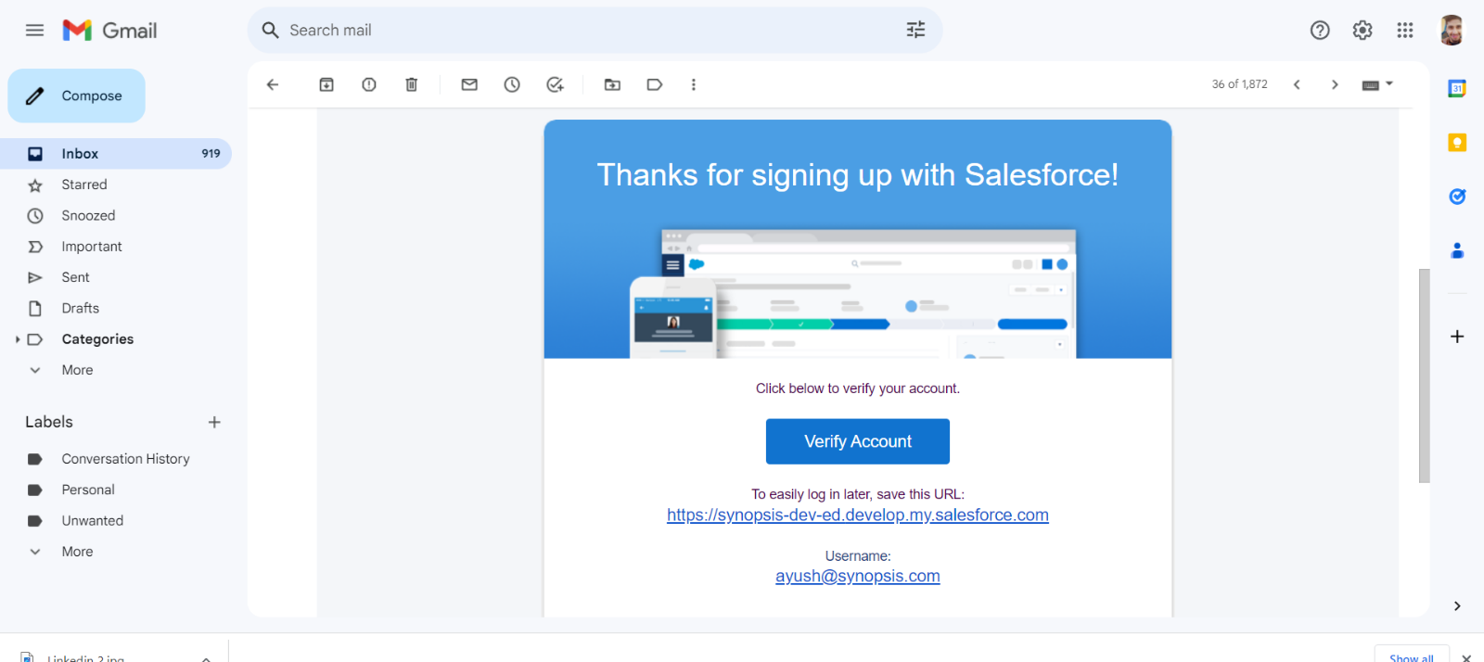

### Creation Of Semester Object for Candidate Internal Result Card

* Create a custom object for **Semester, Candidate, Course Details, Lecturer Details**, and **Internal results.** We can simply create a custom object by following these steps.
* Click on the gear icon and then select Setup.
* Click on the object manager tab just beside the home tab.
* 3. After the above steps, have a look on the extreme right you will find a Create Dropdownclick on that and select    Custom Object.
* On the Custom Object Definition page, create the object as follows:
* Label: **Semester**
* Plural Label: **Semesters**
* Record Name: **Semester Name**
* Check the **Allow Reports**
* Check the **Allow Search**
* Click Save.

Simply create the required custom object

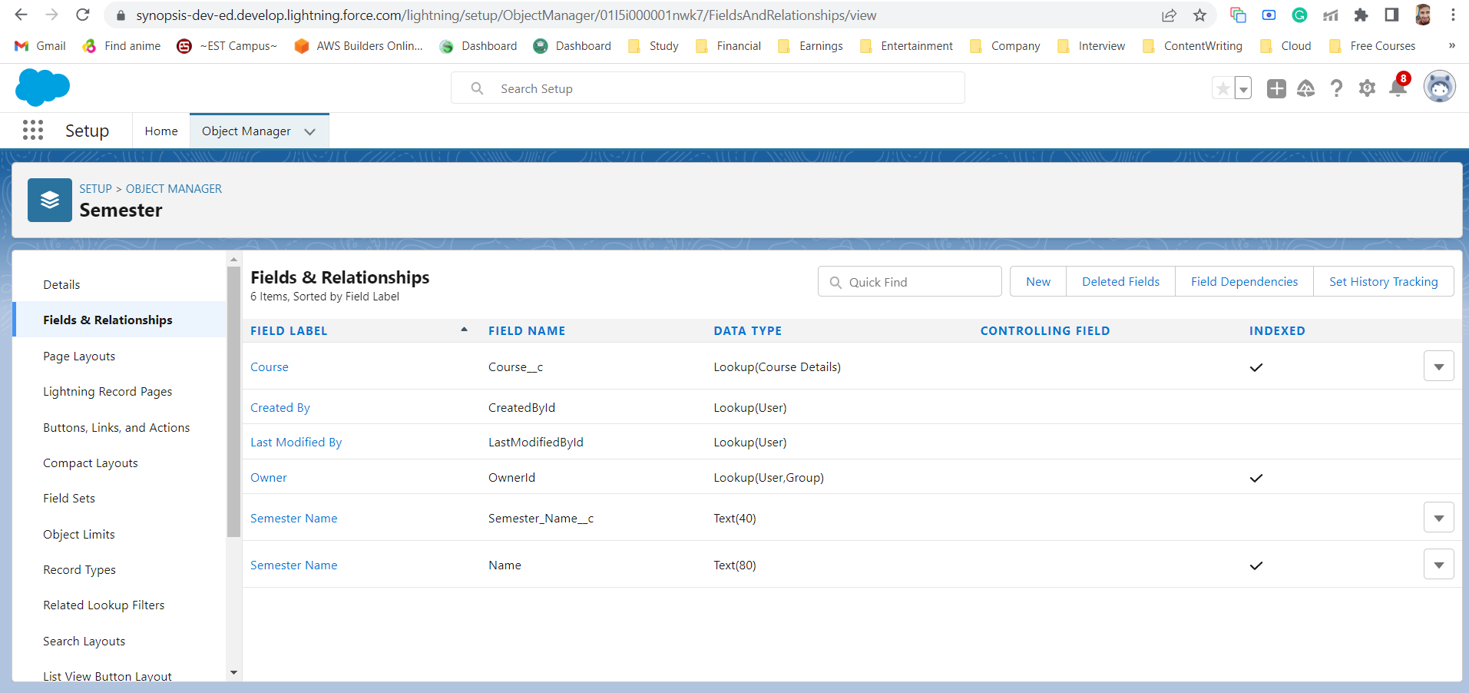

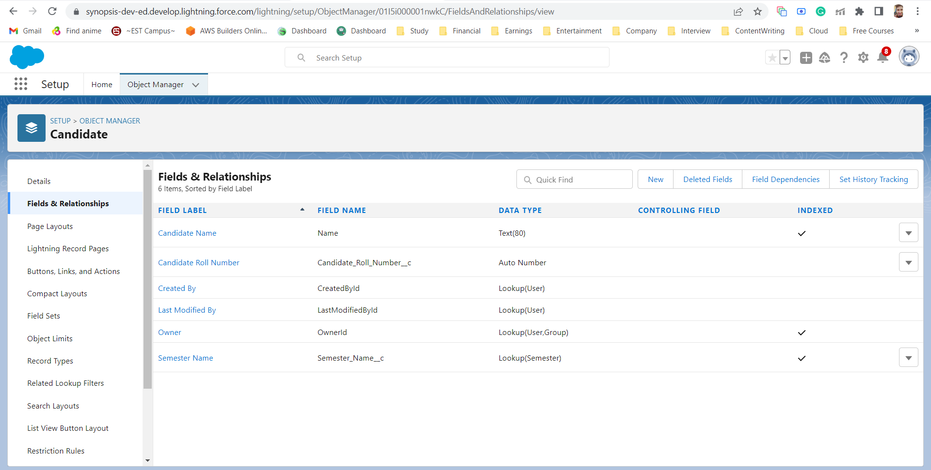

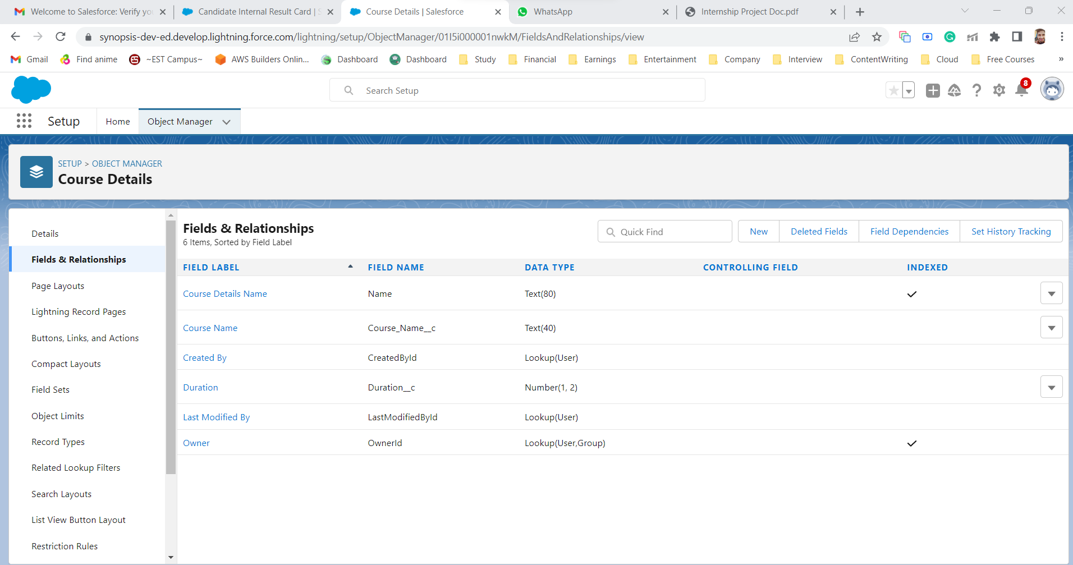

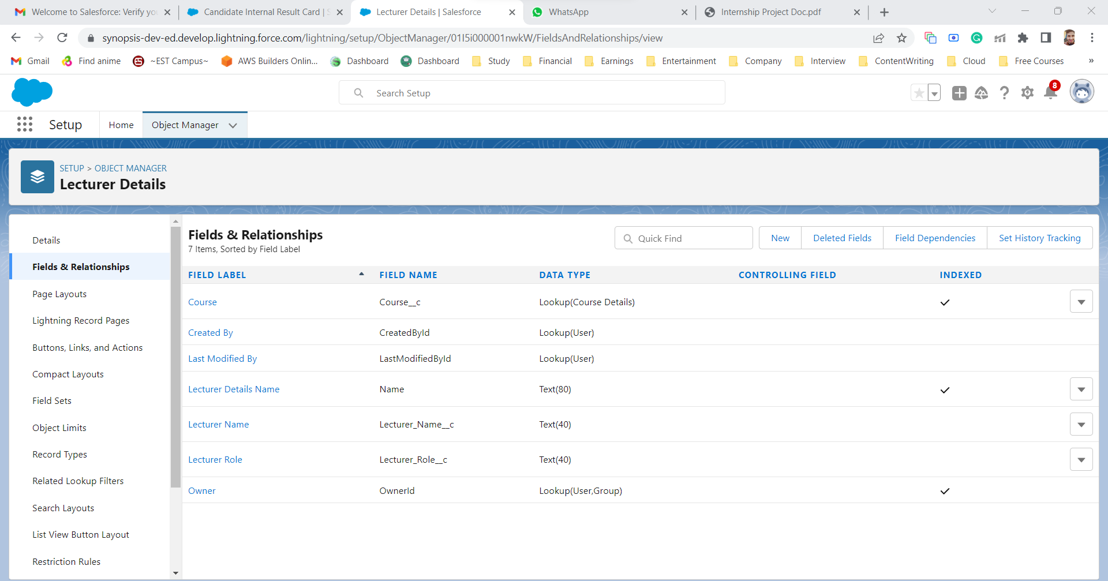

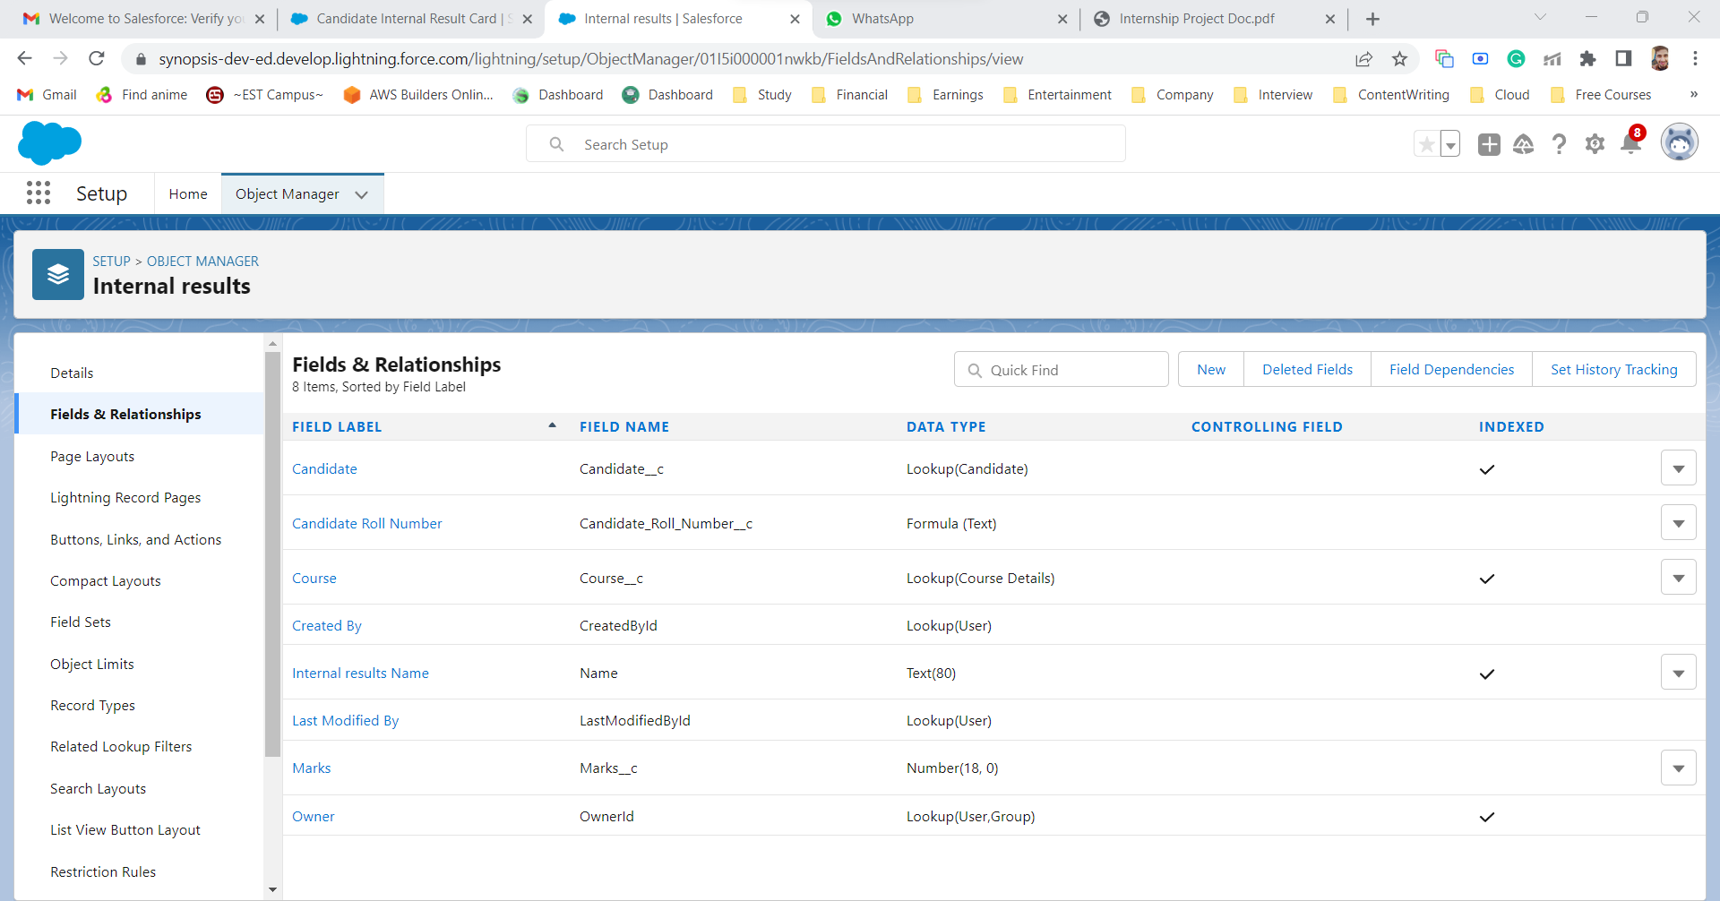

### Creation Of Semester Tab

create a **Semester** tab by following these steps

* Enter Tabs in Quick Find and select Tabs.
* Under Custom Object Tabs, click New.
* For Object, select **Semester**.
* For Tab Style, select any icon.
* Leave all defaults as is. Click Next, Next, and Save
* In the same way create Tabs for all Custom Objects -Candidate, Course Details, Lecturer Details, and Internal results.

After completion the result will look like these: -

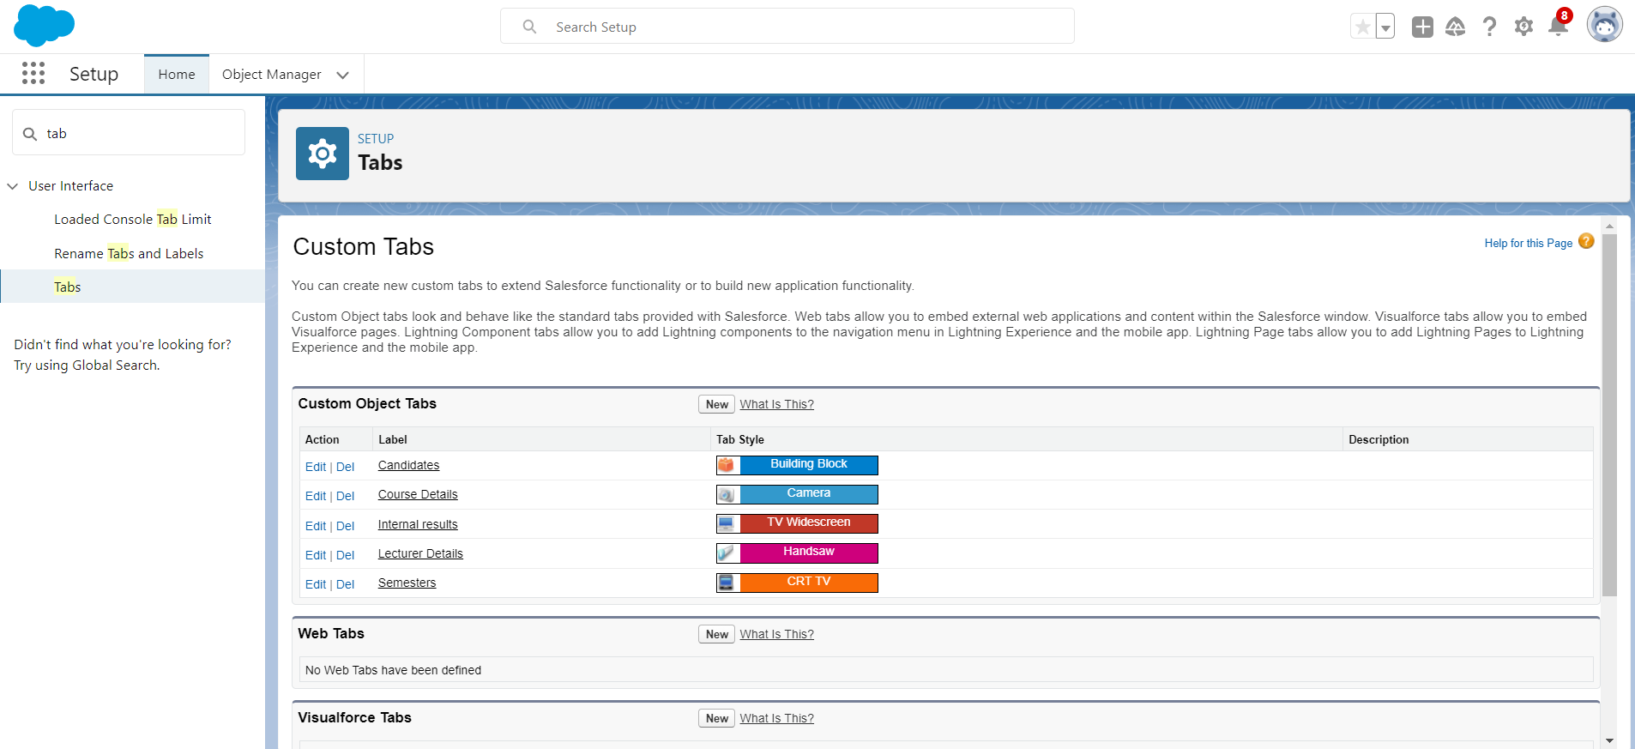

### Create The Candidate Internal Result Card

Candidate’s Internal Result card is important is needed because it is one of the important parameters of the candidate. After searching App Manager in App Launcher. Click the new lightning App and the interface will look like this

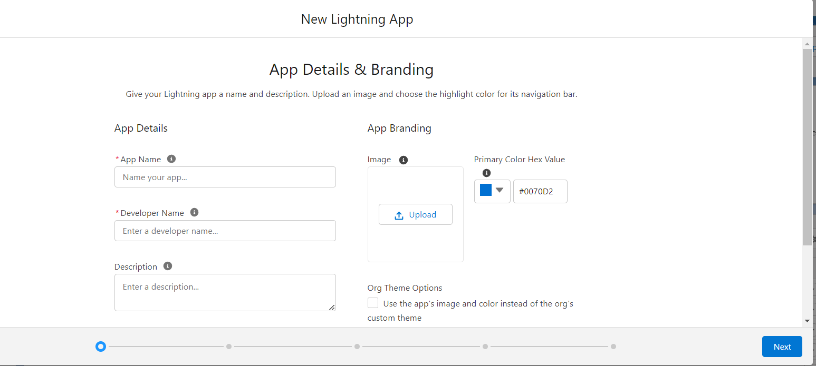

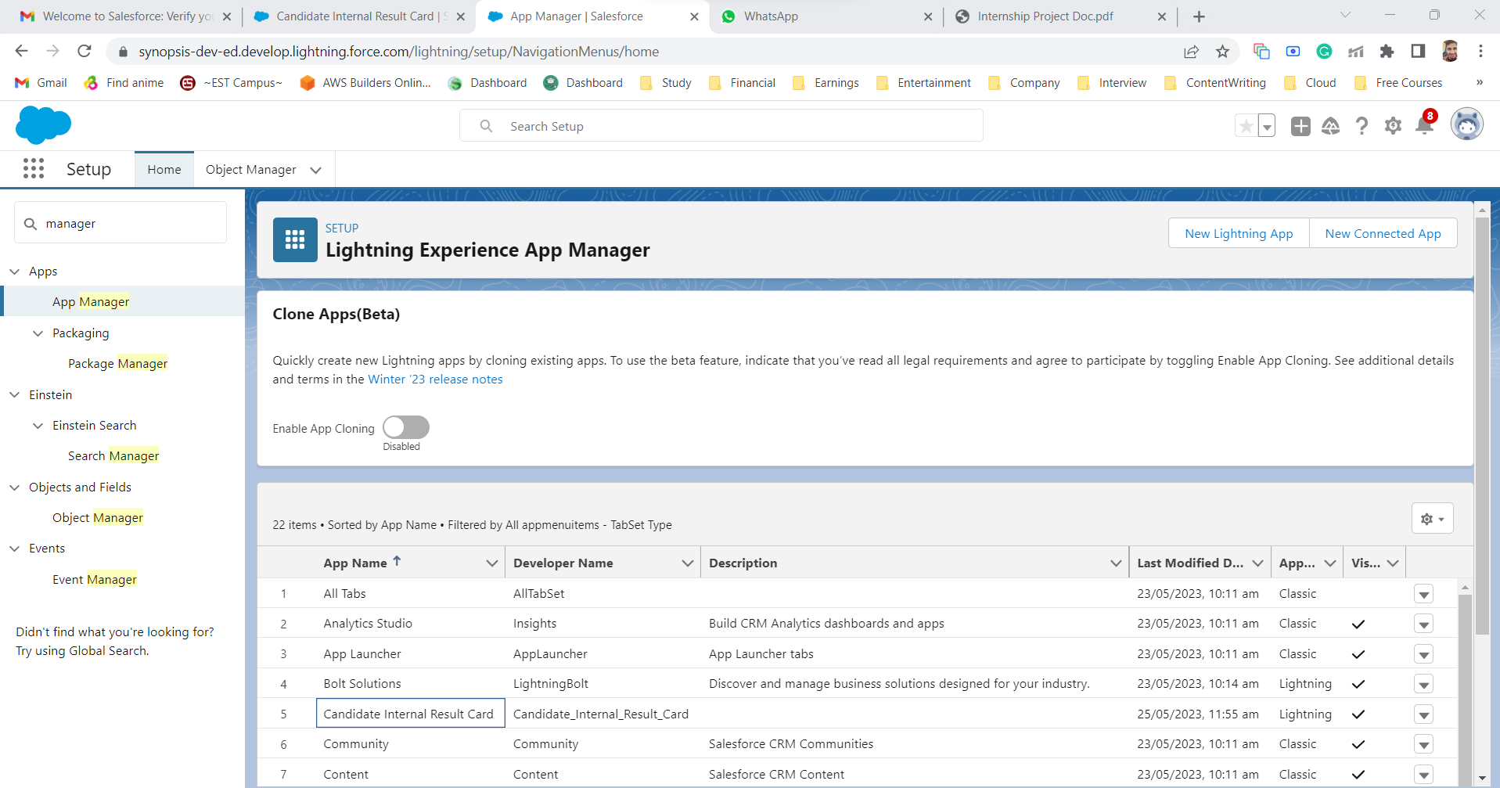

Just follow these steps to proceed to the next step.

* From Setup, enter App Manager in the Quick Find and select App Manager.
* Click New Lightning App.
* Enter **Candidate Internal Result Card** as the App Name, then click next
* Under App Options, leave the default selections and click next.
* Under Utility Items, leave as is and click Next.
* From Available Items, select **Semester, Candidate, Course Details, Lecturer Details, Internal Results, Reports, and Dashboards** and move them to Selected Items.
* Click Next.
* From Available Profiles, select System Administrator and move it to Selected Profiles. Click Save & Finish.

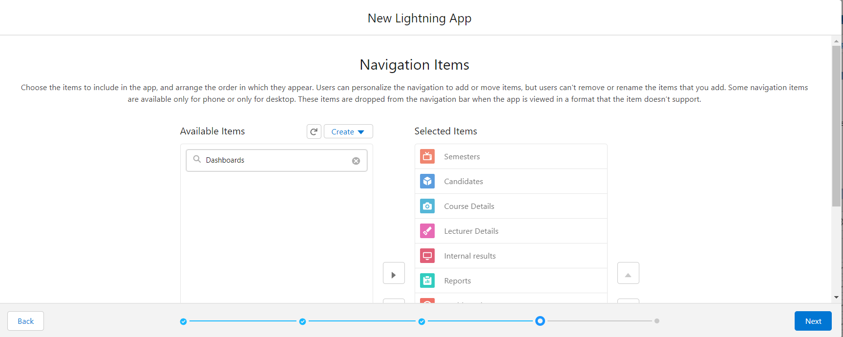

1. **Creating Fields and Relationship**

There are five steps in this process are:-

### Creation Of Text Field For The “Lecturer Details” Object

### Create A Lookup Field On Candidate Object

### Create An Auto Number Field Onthe Candidate Object

### Create A Number Field On Course Detail Object

### Create A Formula Field On Internal Results Object

### 

### 

### Creation Of Text Field For The “Lecturer Details” Object

1.Click the gear icon and select Setup. This launches Setup in a new tab.

2.Click the Object Manager tab next to Home.

3.Select **Lecturer Details**

4.Select Fields & Relationships from the left navigation

5.Click New

6.Select the **Text**as the Data Type, and click next.

7.For Field Label, enter **Lecturer Role**

8.Enter Length 40

9.Click Next, Next, then Save & New.

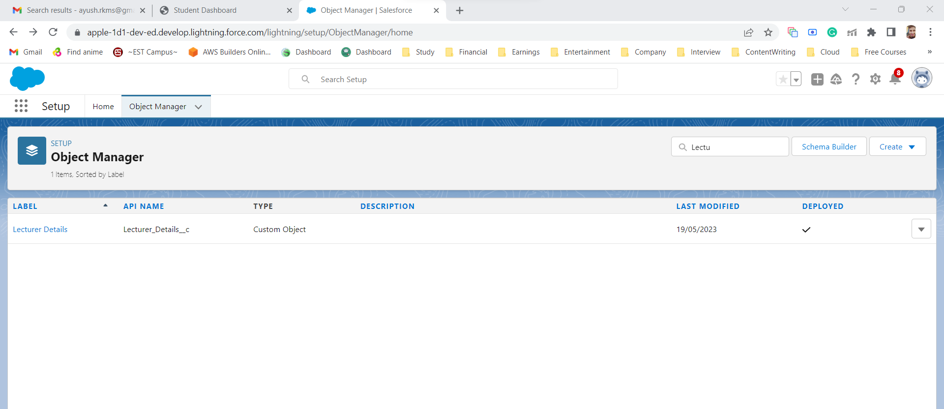

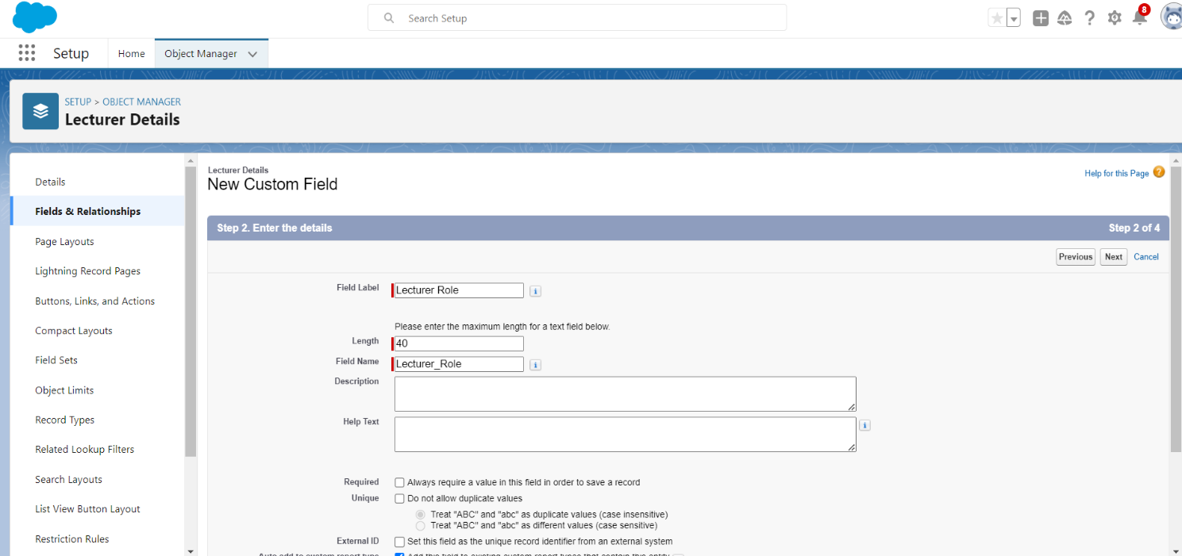

### Create A Lookup Field On the Candidate Object

1.Click the gear icon and select Setup. This launches Setup in a new tab.

2.Click the Object Manager tab next to Home.

3.Select **candidate**.

4.Select Fields & Relationships from the left navigation

5.Click New

6.Select the lookup as the Data Type, then click Next.

7.In related select **Semester**

8.For Field Label **Semester Name**, enter.

9.Click Next, Next, then Save & New.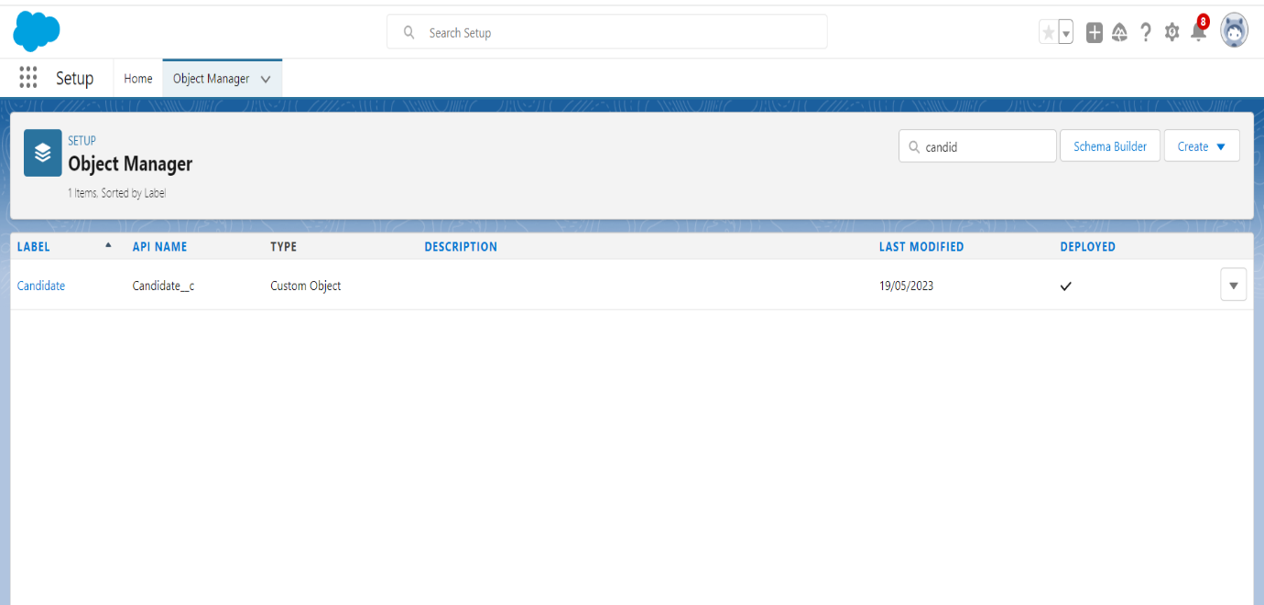

### 

### 

### 

### Create An Auto Number Field On Candidate Object

1.Click the gear icon and select Setup. This launches Setup in a new tab.

2.Click the Object Manager tab next to Home.

3.Select **Candidate.**

4.Select Fields & Relationships from the left navigation

5.Click New

6.Select the lookup as the Data Type, then click Next.

7.In related select Semester

8.For Field Label Semester Name, enter.

9.Click Next, Next, then Save & New.

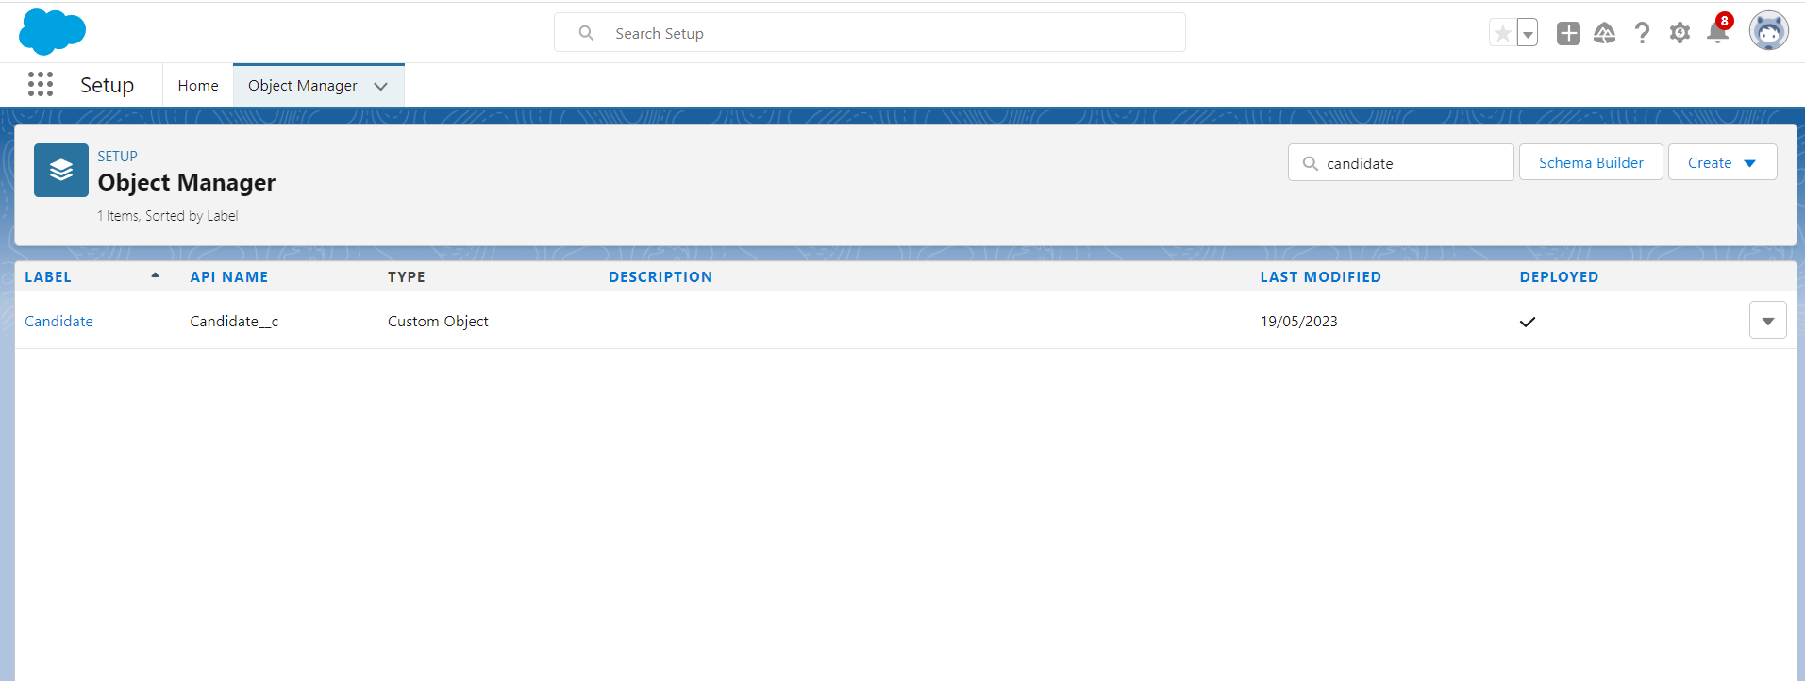

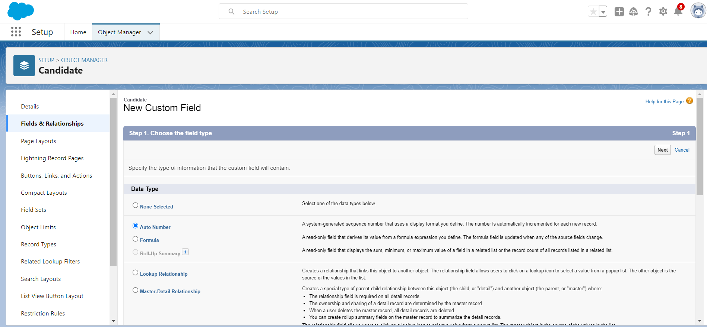

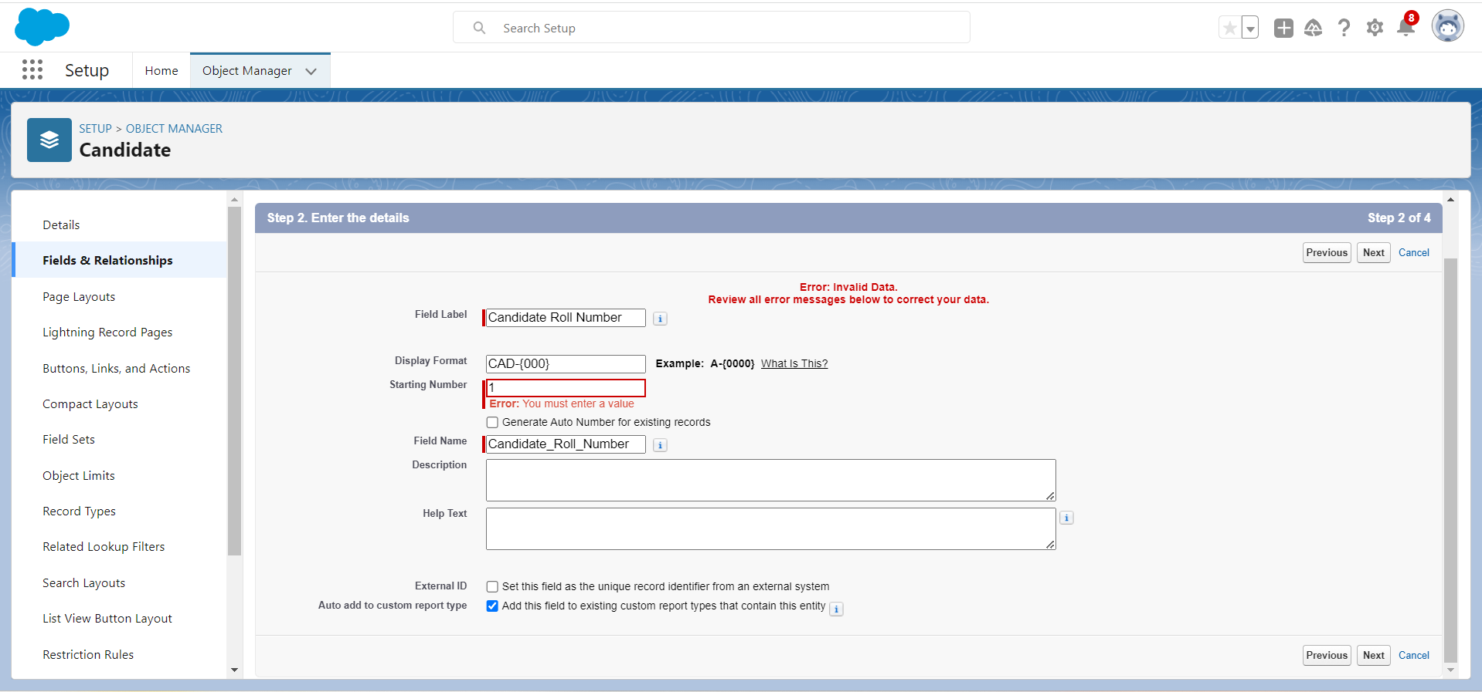

### Create A Number Field On Course Detail Object

1.Click the gear icon and select Setup. This launches Setup in a new tab.

2.Click the Object Manager tab next to Home.

3.Select Course Detail.

4.Select Fields & Relationships from the left navigation

5.Click New & select number field, click Next

6.For Field Label Duration, enter.

7.**Give Help Text- Enter Course duration value in Years**

8.Click Next, Next, then Save & New.

### 

### 

### 

### Create A Formula Field On Internal Results Object

### 1.Click the gear icon and select Setup. This launches Setup in a new tab.

### 2.Click the Object Manager tab next to Home.

### 3.Select Internal results.

### 4.Select Fields & Relationships from the left navigation.

### 5.Click New

### 6.Select the Formula as the Data Type, then click Next

### . 7.Give field label Candidate Roll Number

### 8.Select formula return type text, Click Next

### 9.Click Insert Field

### 10.Create and insert formula Candidate r.Candidate_Roll_Number   c, and then click Insert.

### 11.Click Next, Next, then Save.

### 

### 

### 

### 

### Creating A User

### Creation of Record (Course Details)

### Creation of Report

### 

### 

### Creation of Dashboard

